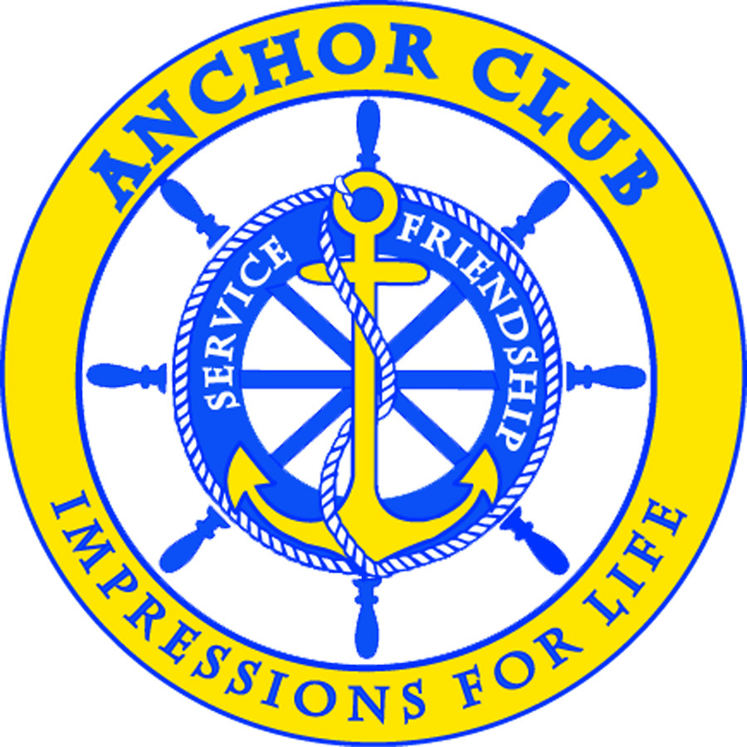
Certificate of Membership

is an honored member of

Anchor Club International

in accordance with the Constitution and Bylaws of this organization and is entitled to all rights and privileges of membership.
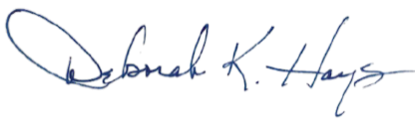

This day of 2019
2019-2020 Pilot International President

Pilot International transforms communities by:
Developing youth, providing service and education and uplifts families

